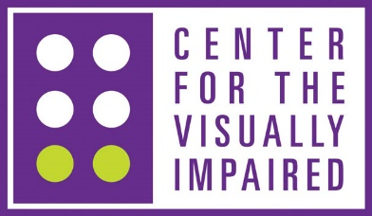
JOB POSTING Nov2022
Assistive Technology
Qualifications
Bachelor’s or master’s degree in education, special education, or related human service field from an accredited college or university. Additional skills and knowledge of instructional levels in computers and/or assistive technology. CATIS, CVRT, TVI, COMS, CVLVT, OTR/L, COTA/L, NOMC or NCRTB Certification with documentation of academic coursework and work history demonstrating ability to teach the technology being taught. Or RESNA as a Certified Assistive Technology Professional (ATP) with extensive hands on knowledge of technology being taught.
Summary of Responsibilities
The planning, assessment, development, and implementation of assistive technology skills necessary to empower individuals with vision loss in their vocational, educational, and daily living.
Duties & Responsibilities
- Performs assessment and provides instruction in techniques that will meet the specific needs of each individual client.
  - Plans and develops individualized instructional objectives based upon needs, goals, and capability of each client.
  - Develops instructional plan that includes sequential learning, development of skills and instructional sessions that will meet the goals of the client.
  - Provides instructional settings in the facility and in the home, work or educational setting that is most relevant to the needs of the client.

- Submits necessary written evaluations, lesson plans, instructional observation notes, progress reports, and final reports in the achievement of individualized plan.
  - Documents all necessary reports and client data in a timely manner in compliance with reporting requirements.
  - Maintain written progress reports including observations and comments on both the acquisition of skills and difficulties encountered and in the remediation of specific problems encountered.
  - Provides communication with team members , supervisors, managers, and any other staff to facilitate the continued progress of the individual.

- Provides information and expertise on assistive technology services to various professional and community resources.
  - Participates in agency/client meetings and presentations to professional groups.
  - Engages in conferences, workshops, seminars, and community educational presentations.
  - Provides consultation and education to consumers, spouses, and family members regarding advocacy and reinforcements that can be developed to assist the individual.

Submit qualifications/resume to: humanresources@cviga.org
No phone calls please.

